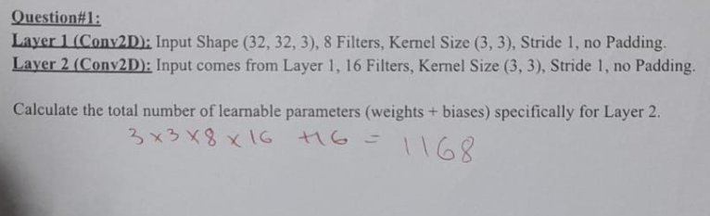
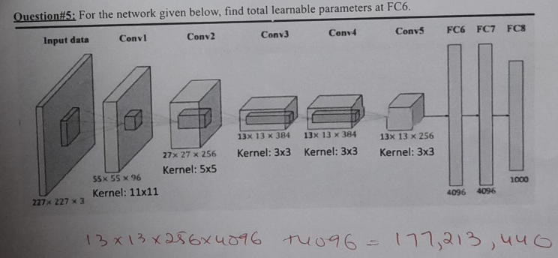

Part a: Output Dimensions
Compute the output size after each layer:
- After first convolution
- After first pooling
- After second convolution
- After second pooling
Part b: Number of Parameters
Compute total trainable parameters in:
- First convolution layer
- Second convolution layer

